Delta Green
God’s Teeth - Go Forth
by FaceplateVTT

Character Dossiers
(in alphabetical order)
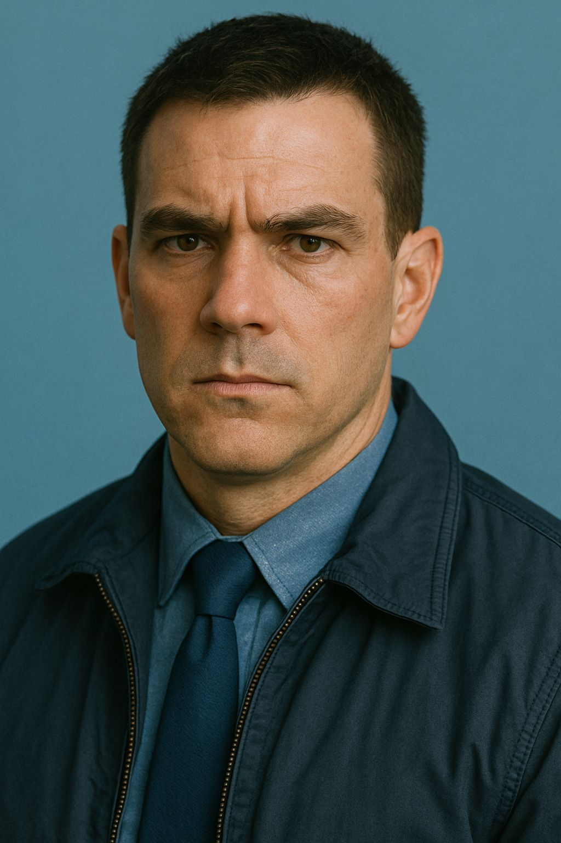

Deputy U.S. Marshal Anderson Fowler
Security Studies Group
Deputy U.S. Marshal Anderson Fowler
Security Studies Group

PHYSICAL DESCRIPTION: Lean, well-built Caucasian male with sharp blue eyes and a hard, assessing stare. Dark brown hair, kept short and practical. Carries himself with a coiled, controlled intensity.
PHYSICAL DETAILS: None. 34yo, DOB 31 AUG 1966

SECURITY CLEARANCE: TS/SSBI
PAYGRADE: GS-12

PERSONAL DETAILS: Raised in a fractured household in Baltimore County, left home at eighteen and never meaningfully returned. Keeps most relationships at arm’s length, maintaining contact with only a small circle, including a younger brother who remains on the margins of legality. By 2001 he already shows signs of becoming insular and difficult, prioritizing control and self-reliance over stability.
ADDITIONAL DETAILS: Has a young son from a dissolved relationship, though involvement is inconsistent and often secondary to work. Prone to anger when challenged, but capable of surface-level charm when it serves a purpose.

CAREER HISTORY:
- June 1984: High School Diploma, Kenwood High School, Essex, MD
- 1987–1988: Baltimore County Police Academy
- 1988–1993: Patrol Officer, Baltimore County PD
- 1993: USMS Application & Training, FLETC Glynco
- 1993–1996: Deputy U.S. Marshal, District of Maryland, General Operations
- 1996–2000: Deputy U.S. Marshal, District of Maryland, Fugitive Investigations Unit
- 2000–2001: Deputy U.S. Marshal, District of Maryland, Regional Fugitive Task Force (Baltimore)
- August 2016: Optional retirement under 5 U.S.C. Chapter 83/84
- August 2023: Mandatory retirement under 5 U.S.C. Chapter 83/84

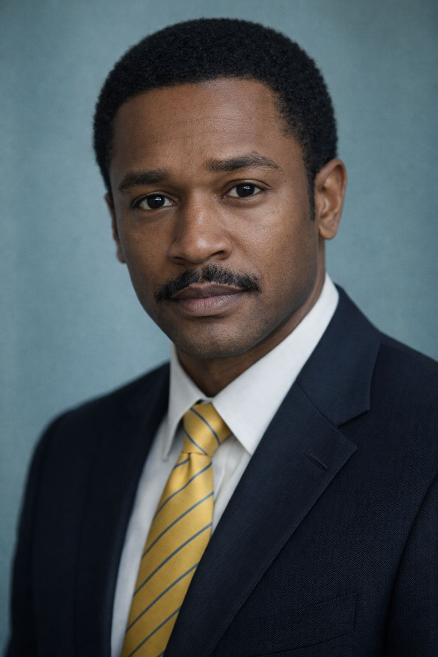

DEA Special Agent Darius Jeremiah Cruz
Security Studies Group
DEA Special Agent Darius Jeremiah Cruz
Security Studies Group

PHYSICAL DESCRIPTION: Tall and dark with a short haircut. A thick moustache droops to his lips from his nose. Well built.
PHYSICAL DETAILS: Left-handed. 34yo, DOB 28 JAN 1967

SECURITY CLEARANCE: Secret
PAYGRADE: GS-11 (Journeyman DEA Special Agent)

PERSONAL DETAILS: Darius could be the polished side of the coin called the decline of Black America. Coming from a relatively successful family of a teacher and a midwife, he served the urge to help others and pull a fellow man up back on his feet from his knees, until tragedy struck. Perfect grades and a warm personality in the time when civil rights movement was giving its fruits made for a smooth ride, soon he became a generalist surgeon at an ER. Marrying Sarah sometime during the process, the circle of life was coming to a complete loop.
In 1998, his brother Malcolm was found dead to a fentanyl overdose in his room in a group-living program. Facing the cold reality that all his effort could not prevent such an outcome, Darius decided to opt in for a more hands-on approach in the Drug Enforcement Administration.

ADDITIONAL DETAILS: Hides the overwhelming grief of loss quite well. Often friendly with everyone, perhaps even treading into the goofy territory. Dresses incredibly loud when not at work, his favorite article of clothing being a thrice-thrifted tie dye shirt with the word “bodacious” airbrushed onto it. Jokingly claims to hold the world record for the “mightiest bench press” whenever he gets the chance.

CAREER HISTORY:
- June 1986: High School Diploma, Shaker Heights High School, Ohio
- May 1990: Bachelor of Sciences of Pharmaceutical Sciences at Ohio State University
- May 1994: Medical Doctor at Case Western Reserve University
- 1994–1998: General Surgery Residency at University Hospitals Cleveland Medical Center
- 1998: DEA Recruitment & Training
- 1998–? DEA Cleveland Field Office, Diversion Group, Independent Case Agent
- January 2024: Mandatory retirement under 5 U.S.C. Chapter 83/84 (ineligible for optional)
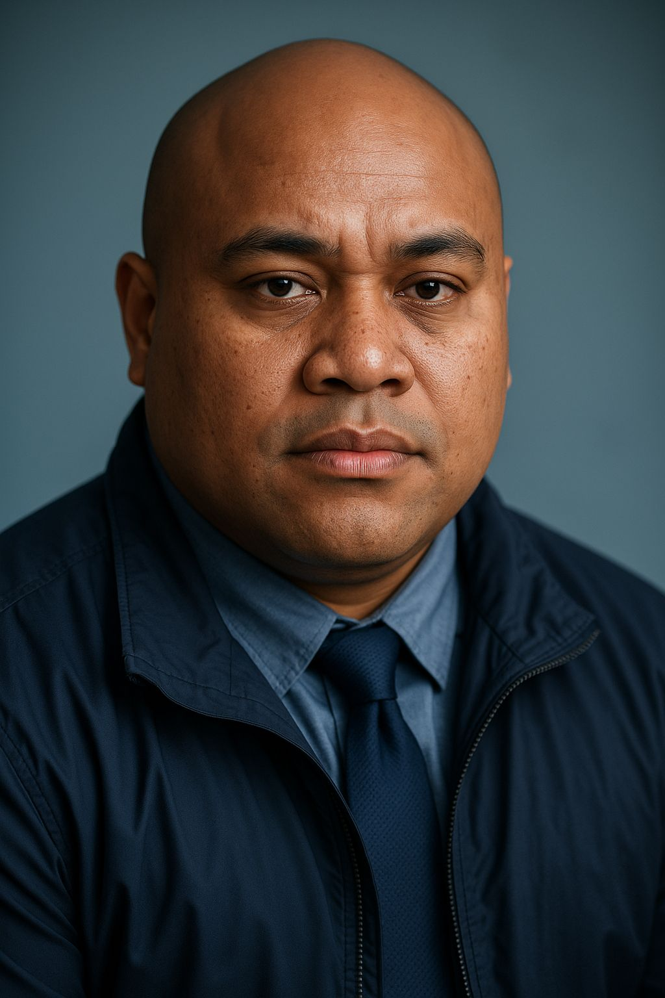

Deputy U.S. Marshal George Elijah Jones
Security Studies Group
Deputy U.S. Marshal George Elijah Jones
Security Studies Group

PHYSICAL DESCRIPTION: Tall and heavily built, with a shaved or closely cropped haircut. Broad features and a strong frame. Physically imposing without appearing aggressive.
PHYSICAL DETAILS: None. 31yo, DOB 12 APR 1970

SECURITY CLEARANCE: Secret
PAYGRADE: GS-11

PERSONAL DETAILS: George Jones was born and raised in Virginia, adopted at a young age into a stable household. He grew up with a strong sense of responsibility and structure, shaped by both family expectations and community environment. After high school, he enlisted in the U.S. Army Reserve, serving in a transportation and logistics role while pursuing higher education. He completed a degree in criminal justice and transitioned into local law enforcement, working first in probation and parole before moving into patrol.
Jones’ early career reflects a consistent focus on direct, practical work. He does not display interest in specialization for its own sake, instead gravitating toward roles where outcomes are immediate and measurable. His transition into the U.S. Marshals Service was motivated by a desire for more active involvement in apprehension and enforcement. He adapts quickly to operational environments and demonstrates reliability under pressure.
His personal life is stable. He maintains close relationships with family and is socially functional, with no noted issues in maintaining bonds or external commitments.

ADDITIONAL DETAILS: Approachable and personable, Jones integrates easily into team environments. Maintains a calm demeanor in stressful situations and is not prone to escalation without cause. Demonstrates strong physical capability and willingness to engage directly when required. Not notably analytical, but consistently effective in practical application.

CAREER HISTORY:
- June 1988: High School Diploma, Bethel High School, Hampton, VA
- September 1988: U.S. Army Reserve Enlistment – Transportation / Logistics Support (Fort Eustis, VA)
- May 1992: Bachelor of Science in Criminal Justice, Virginia Commonwealth University
- November 1992: Honorable discharge
- 1993: Tidewater Regional Police Academy, VA
- 1993–1995: Probation & Parole Officer, Richmond Police Department, VA
- 1995–1997: Patrol Officer, Richmond Police Department, VA
- 1997: USMS Application & Training (FLETC Glynco, GA)
- 1998–2001: Deputy U.S. Marshal, Eastern District of Virginia, Fugitive Task Force
- April 2027: Mandatory retirement under 5 U.S.C. Chapter 83/84 (ineligible for optional)
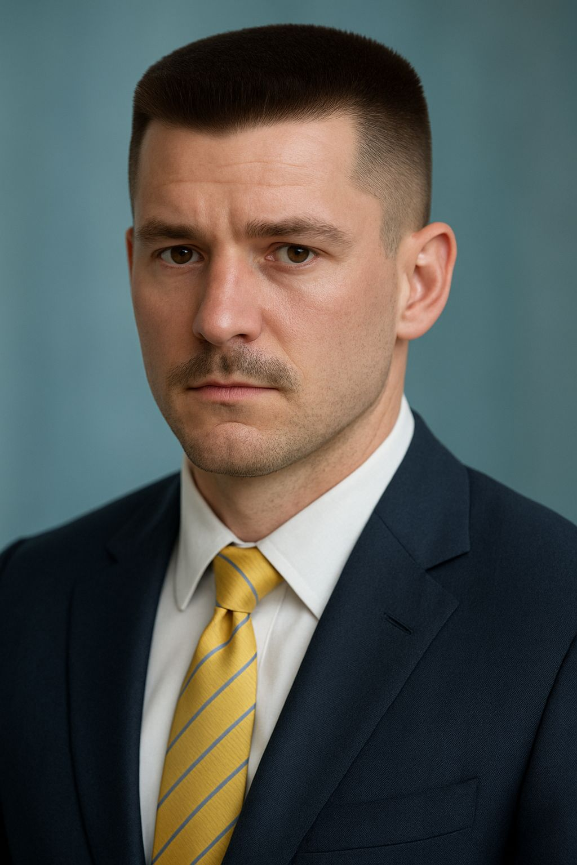

ATF Special Agent Keith Alan Pike
Security Studies Group
ATF Special Agent Keith Alan Pike
Security Studies Group

PHYSICAL DESCRIPTION: Lean-faced. Several years committed to a naturally weak mustache. Flat top hair has escaped Army regulation but remains permissibly professional. Documented tattoos behind the wrist line.
PHYSICAL DETAILS: None. 29yo, DOB 09 JUN 1972

SECURITY CLEARANCE: TS/SCI
PAYGRADE: GS-11

PERSONAL DETAILS: A byproduct of American interventionism and the collapse of Michigan's manufacturing industries. After spending close to two years in college, Keith enlisted in the Army to fulfill two childhood dreams, to work with animals for a living, and to be a policeman. Neither was what he expected: His beloved "Samson" died in the outskirts of Mogadishu when a security patrol became the victim of an IED-initiated ambush. Over the remaining months of his deployment, the local people paid a grievous price in "security operations" against collaborators through search-and-seizure missions inside their homes. He doesn't believe it will ever be enough. Magnetized to the intensity of 'counterinsurgency', he deployed to Port-au-Prince in the American bid to re-instate the elected government, embedded with Haitian police patrols in an urban environment he found agitatingly similar to the one he'd left in Africa. Gunfights were room-to-room, unrecorded and underreported, a "show of presence" to assist local law enforcement. Finishing his degree while sitting in a recruiter's pocket, the ATF found him a keen fit, furnishing him with a badge and a dog after a model transition from service featuring the GI bill.

ADDITIONAL DETAILS: He is increasingly estranged from his wife, formerly his high school girlfriend, who's occasional attendance at church metamorphized into an evangelical obsession while he was away. She instigates conversations about living a "Christ-centered lifestyle", for Keith, nothing felt so sacred after Somalia, but he still dutifully attends cookouts and study sessions to keep his family intact. Roy and Anne occupy an increasingly large portion of his heart as CONUS law enforcement gradually hardens it.

Duke, four years and change, is a Malinois. Black-faced, tawny-bodied, and mimics Keith's body language with intent.

CAREER HISTORY:
- June 1990: High School Diploma, Marquette Senior High School, Michigan
- September 1990: U.S. Army Enlistment as Military Police (31B predecessor) with K-9 specialization
- 1993: Somalia Tour of Duty (UNITAF/UNOSOM II)
- 1994: Haiti Tour of Duty (Operation Uphold Democracy)
- December 1994: Honorable discharge
- May 1997: Bachelor of Arts of Criminal Justice at Northern Michigan University
- 1997–1999: ATF Recruitment & Training
- 1999–2000: ATF Detroit Field Division, General Casework
- 2000–2001: ATF Detroit Field Division, Explosives Detection K-9 Program
- June 2022: Optional retirement under 5 U.S.C. Chapter 83/84
- June 2029: Mandatory retirement under 5 U.S.C. Chapter 83/84

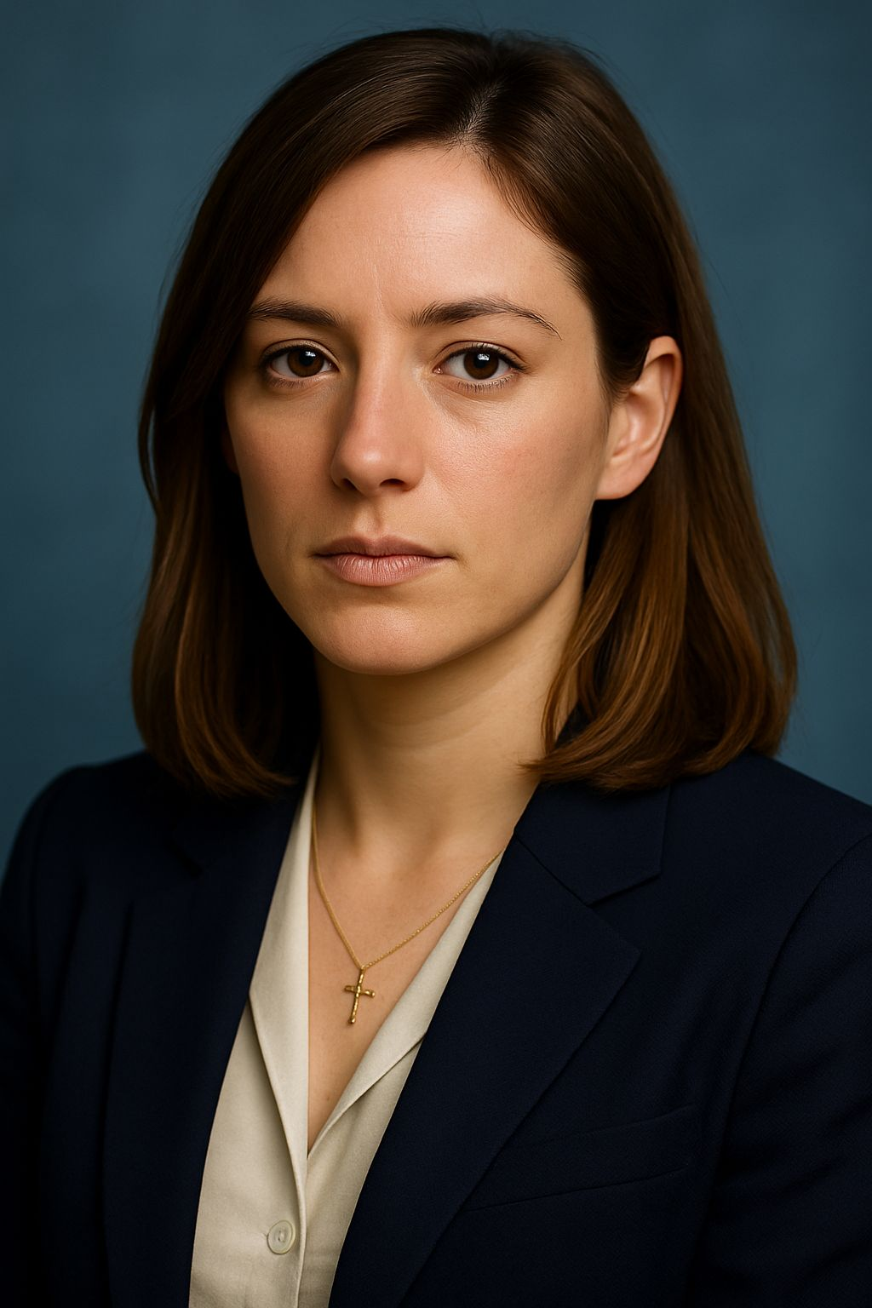

FBI Special Agent Mariam Helena Khoury
D-Cell – Agent Diana
FBI Special Agent Mariam Helena Khoury
D-Cell – Agent Diana

PHYSICAL DESCRIPTION: Tall, athletic woman with sharp Mediterranean features and a composed, watchful demeanor. Dark brown hair worn short and practical. Expression tends toward controlled neutrality rather than warmth.
PHYSICAL DETAILS: None. 32yo, DOB 14 NOV 1968

SECURITY CLEARANCE: TS/SCI
PAYGRADE: GS-12

PERSONAL DETAILS: Mariam is a recently tenured Special Agent in the FBI’s New York Field Office, assigned to counterterrorism through the Joint Terrorism Task Force. Her professional outlook is structured and principled, shaped by a mix of academic psychology and exposure to vulnerable populations during her years as a social worker. She approaches cases with a belief that intervention can still produce stable outcomes, focusing on prevention, disruption, and rehabilitation where possible rather than inevitability.
Her background as a Syrian-American informs her understanding of geopolitical instability, but it manifests more as attentiveness than fixation. She is aware of the narratives surrounding the Middle East and terrorism, and is careful not to reduce individuals to those narratives, even when colleagues or external pressures do so. She maintains a quiet but firm alignment with U.S. institutional goals, believing in the system’s capacity to manage complex threats without abandoning its stated principles.
Her personal life is strained by increasing professional demands. She remains in contact with family and participates intermittently in religious and cultural practices, which provide continuity rather than obligation. At this stage, she still maintains a boundary between work and home, though that boundary is beginning to erode under sustained workload.

ADDITIONAL DETAILS: Mariam is regarded as reliable, analytical, and measured in her approach to investigations. She shows a preference for preparation and pattern recognition, often identifying behavioral indicators before they become operational threats. Exposure to high-stress environments produces a visible but contained response, which she manages through discipline rather than suppression. She retains an elevated sense of empathy, especially toward individuals on the margins, though this occasionally slows her decision-making in situations requiring rapid escalation.

CAREER HISTORY:
- June 1986: High School Diploma, Staten Island Technical High School, New York City, NY
- May 1991: Bachelor of Science in Psychology, Rutgers University
1991–1996: Licensed Social Worker (Adolescent Services, NY/NJ)
- 1996–1998: FBI Recruitment Pipeline & Quantico Training
- 1998–2000: FBI Special Agent (Probationary), New York Field Office, Counterterrorism Division
- 2000–2001: FBI Special Agent, NYFO Counterterrorism Division, Joint Terrorism Task Force (JTTF), investigative support and case development
- November 2018: Optional retirement under 5 U.S.C. Chapter 83/84
- November 2025: Mandatory retirement under 5 U.S.C. Chapter 83/84
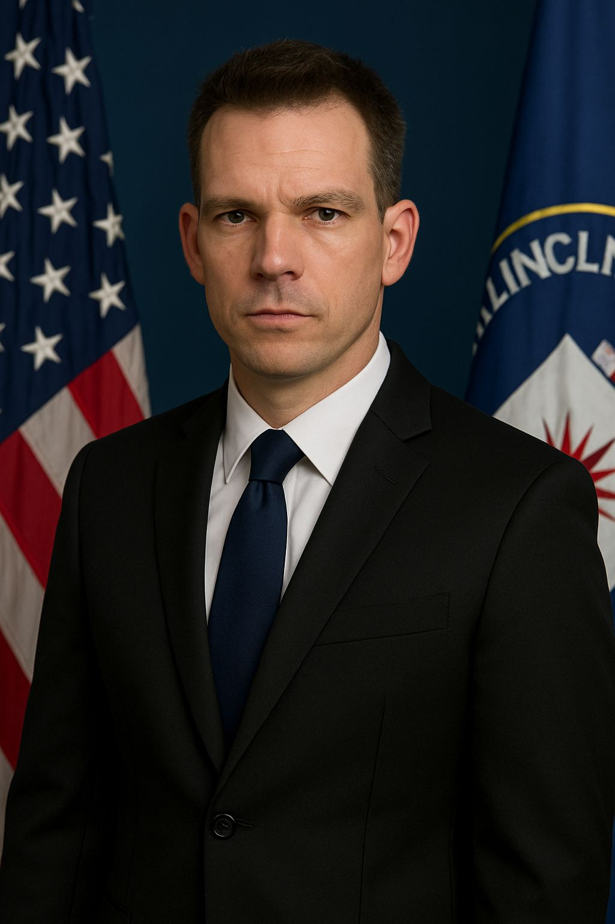

CIA Intelligence Officer Michael Sajdak
Security Studies Group
CIA Intelligence Officer Michael Sajdak
Security Studies Group

PHYSICAL DESCRIPTION: Broad-shouldered European-looking man with a round face and wide, stubby nose. Combed hair and a pronounced widow’s peak.
PHYSICAL DETAILS: Left-handed. 32yo, DOB 05 JUL 1969

SECURITY CLEARANCE: TS/SCI
PAYGRADE: GS-11

PERSONAL DETAILS: Born to Andrzej Sajdak, an ironworker, and his wife Karoline in Philadelphia. A precocious child, Michael was quickly regarded as a savant due to his intelligence and near-mute nature, leading to many fights with a father who wished his only son was more normal. Graduated from Heidelberg University with a thesis on the comparative history of Eurasia before training at Kent Sherman to become a CIA analyst. Married Marie Cardinale at 28, although his unsociable nature and monomaniacal obsession with work quickly caused the marriage to fall through. Their mutual Catholicism means they’re both married on paper but they haven’t actually spoken in years.

ADDITIONAL DETAILS:
In 2000, Marie Luterzo, a Red Brigader hiding in France after the assassination of an Italian state police officer in 1985, was shot dead outside the Rue de Rennes. Following this, Michael was immediately transferred to a domestic post in his home state of Pennsylvania.

CAREER HISTORY:
- June 1987: Stuyvesant High School, New York City, NY
- May 1991: Bachelor of Arts in History, The City University of New York
- May 1993: Master of Arts in History, Heidelberg University
- 1994–1995: CIA Recruitment & Training at Kent Sherman
- 1995–1997: Junior Analyst, Russia/Eurasia Division (CIA Headquarters)
- 1997–1999: Field Analyst, Russia/Eurasia Division (CIA Headquarters)
- 1999–2000: Intelligence Officer, CIA DCI’s Office (Europe & Russia Desk)
- 2001–?: Intelligence Officer, Domestic Posting, Pennsylvania (Undercover as DoC Employee)
- July 2029: Optional retirement under CIA employment framework
- July 2034: Mandatory retirement under CIA employment framework

